**Install TOMCAT In QA & Production Server**

1) Select QA Server and press connect

2) Copy the SSH Command

3) Open GIT Bash & paste the SSH Command

Press Yes

4) Update the apt repository

sudo apt-get update

5) Install tomcat8

sudo apt-get install -y tomcat9

After this we need to install one more package

sudo apt-get install -y tomcat9-admin

6) Check the tomcat is intall or not

Copy the public IP of the QA Server then paste in the browser and in the end enter :8080

qa_server_public_ip:8080

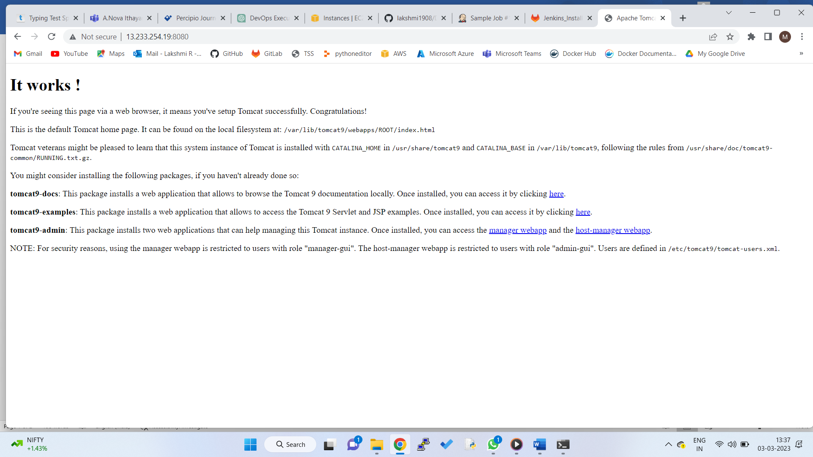

Setting the path of tomcat in jenkins

7) enter linux command in QA Server - cd /etc/tomcat9/

8) enter linux command in QA Server - ls

9) You will find the file tomcat-users.xml

10) Open the file -- sudo vim tomcat-users.xml

11) In the end we need to add one statement

<user username="training" password="abcdabcd" roles="manager-script,manager-status,manager-gui"/>

save and quit

press esc & type :wq & press enter

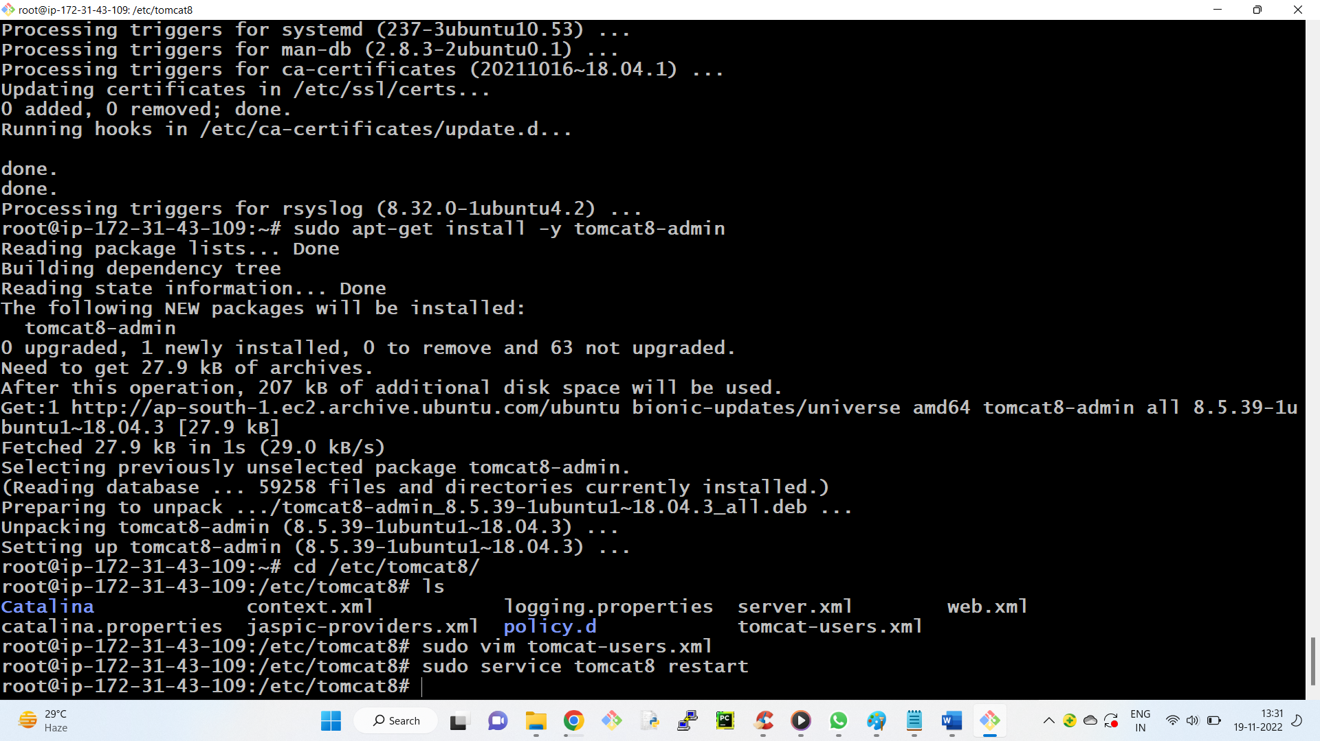

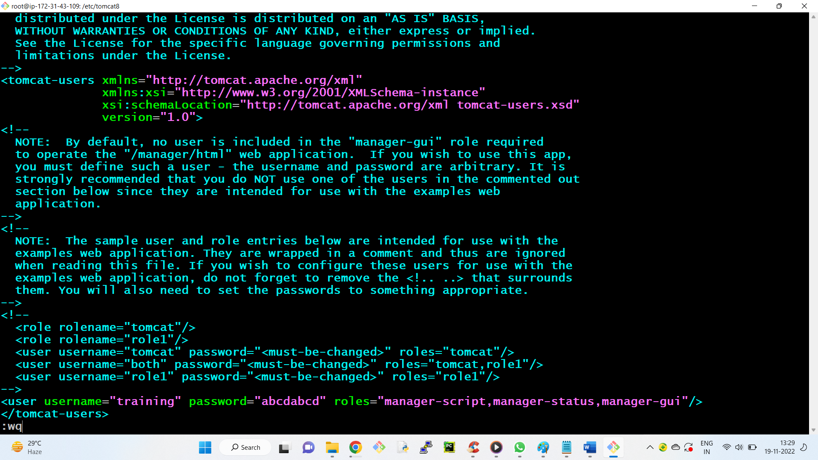

12) Whenever we do any changes done in any service we need to restart the service

sudo service tomcat9 restart

13) After this the same above 12 steps we need to do in the prod server also.

++++++++++++++++++=

Prod Instance

<user username="learning" password="abcdabcd" roles="manager-script,manager-status,manager-gui"/>

